Ryan Fleury

000758292

Senior Projects 2

Project Install instructions

**Development Environment:**

For my IDE I use vsCode but any environment should work.

**Library requirements:**

To run my python GUI, there are first several python libraries that need to be installed within the IDE of your choice. I used VScode but anyone should work if the libraries are installed. Here is the list of the required libraries:

Library Pip install command

* import praw —--------------------------------------------------------------------pip install tk
* import pandas as pd-------------------------------------------------------------pip install pandas
* from nltk.corpus import words—--------------------------------------------pip install nltk
* from sklearn.feature_extraction.text import TfidfVectorizer---------pip install tfidf
* from tkinter import *------------------------------------------------------------pip install tk
* from tkinter import filedialog—-----------------------------------------------pip install tk
* from textblob import TextBlob------------------------------------------------pip install textblob
* import json-------------------------------------------------------------------------pip install json
* from sklearn.feature_extraction.text import TfidfVectorizer----------pip install sklearn
* from sklearn.feature_extraction.text import TfidfVectorizer----------pip install tfidf
* import praw------------------------------------------------------------------------pip install praw
* import docx ------------------------------------------------------------------------pip install docx

**In python terminal:**



Once all of the libraries are installed the file that should be run is called GUI.py. This file will start the program. Here is a screenshot of the execution.

File Location in folder:

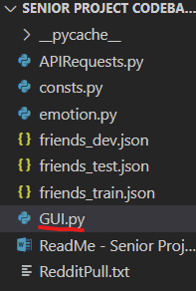

Command:

This is the command I use to run the program in VScode. Everything in yellow can be replaced with “python” on a typical system setup. Furthermore, the directory will be changed depending on file location on your system.